Manual and automated testing

Manual testing for user stories.
Both user stories follow the same path of booking online so the result is generic. The website must allow the user to get to and fill out the booking form.
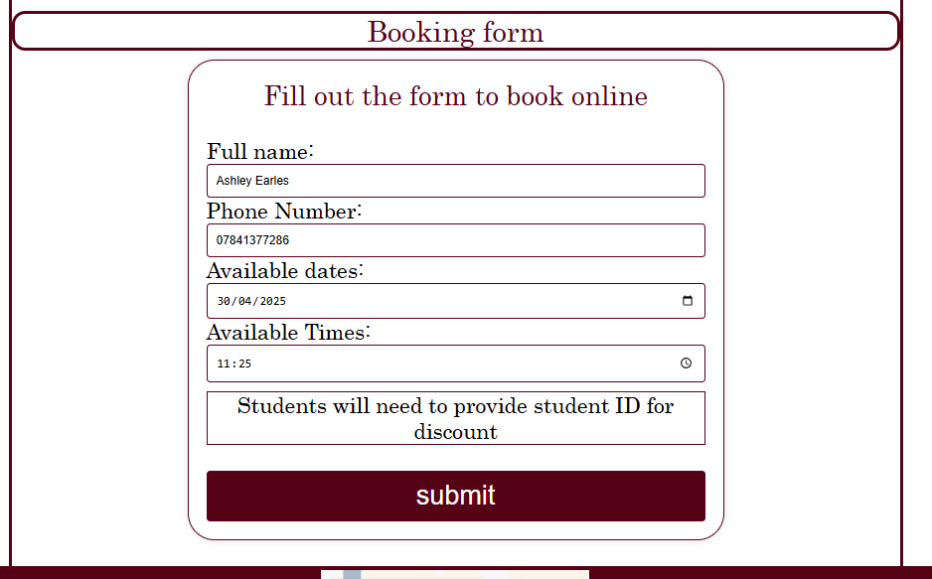
The website allows the user to book online by filling out the booking form. This means that the website plays its role in achieving the user stories.
Student discount is a big part of what my website is offering and promoting this student discount throughout the website is crucial. Each webpage has student discounts promoted on it.
Home page and booking form page on the right box has student discount promotions
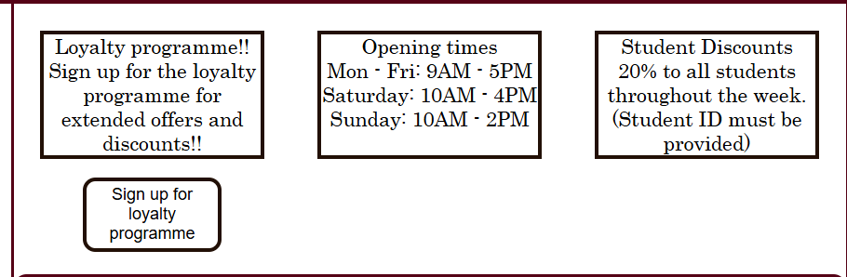

Booking page has additional student discount promotions near the booking elements.


Automated testing.
Using lighthouse within google chrome to test the pages. Anything that not marked green will be assessed.

FalsePage
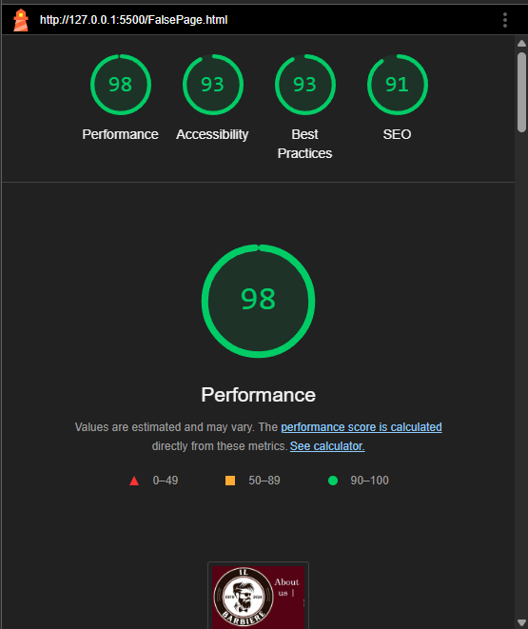

Home page
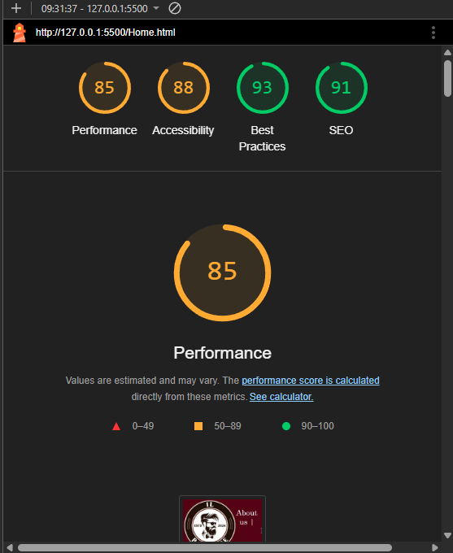

Majority of the issues come with the images being saved in an older gen format. Resaving the images to a jpeg file solved majority of the issues leaving accessibility slightly low on the score.

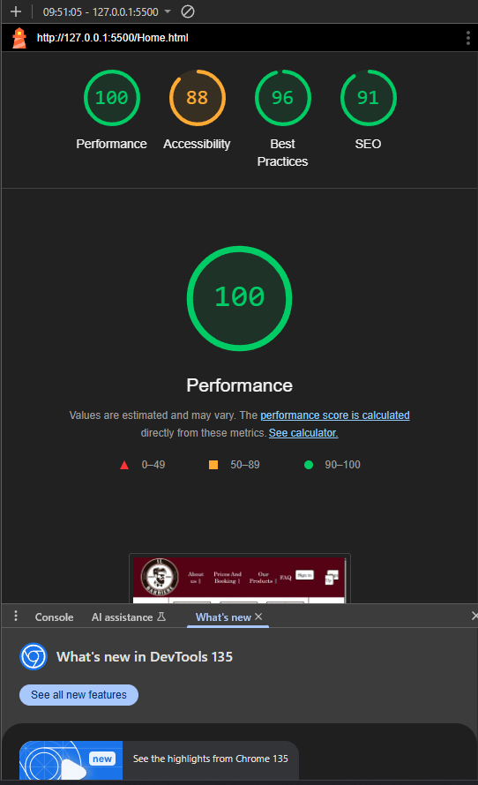

For the accessibility my Iframe tag for the google maps did not have a title element. Changing this resulted in the accessibility becoming green.
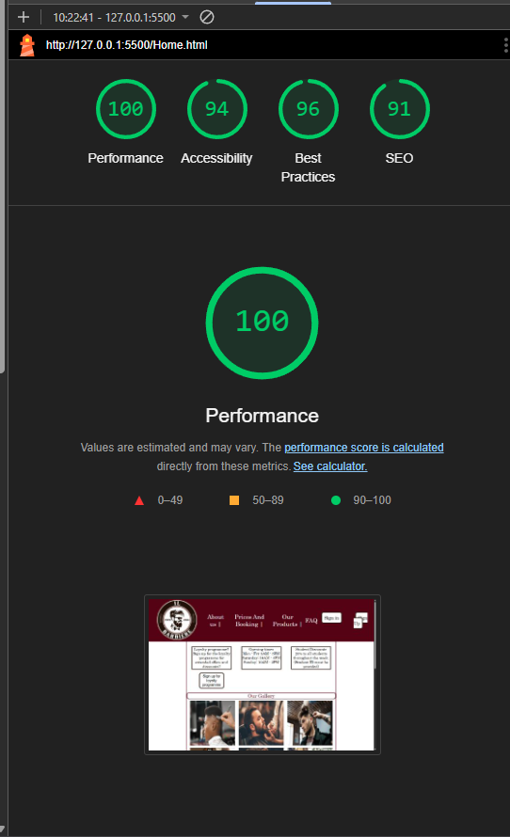

Booking page
After changing the required images to JPEG and adding the title to the maps the booking page comes up green.

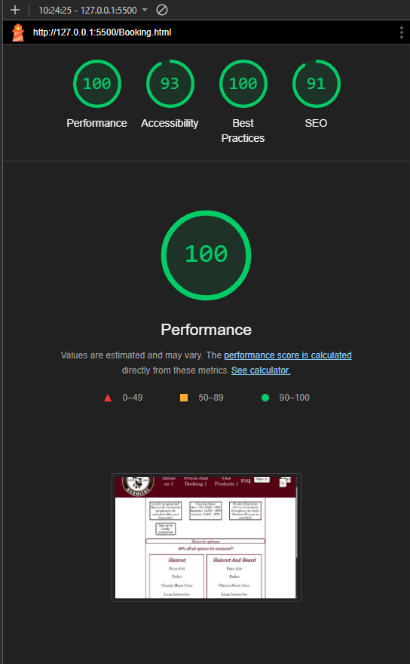

Booking form page
Booking form page has initial accessibility issues.
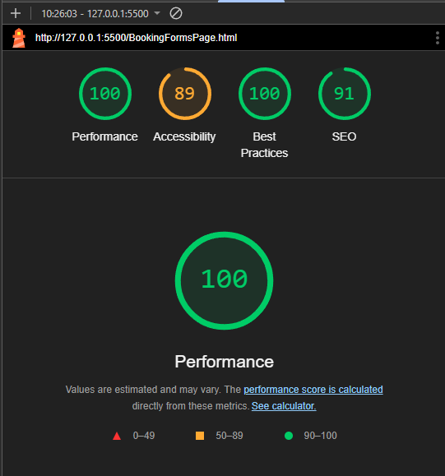

The issue with this one was within the form. The element labels were not in the correct format.
Initial format
Correct format
After changing this for all the form elements the result was 94% in accessibility that I was happy with.
